JAVA COLLECTIONS FRAMEWORK –

1️⃣ What is Java Collections Framework?
The Java Collections Framework (JCF) is a set of classes and interfaces used to store, retrieve, manipulate, and process groups of objects efficiently.

Why Collections?
✔ Dynamic size
✔ Ready-made data structures
✔ High performance
✔ Cleaner, reusable code

2️⃣ Core Interfaces in Collections
Collection
├── List
├── Set
└── Queue

Map (separate hierarchy)

LIST INTERFACE

📌 Characteristics
- Maintains insertion order
- Allows duplicate elements
- Index-based access

📌 Real-life examples
- Shopping cart
- Playlist
- Attendance register

LIST IMPLEMENTATIONS

1️⃣ ArrayList
✔ Fast random access
❌ Slow insertion/deletion (middle)

2️⃣ LinkedList
✔ Fast insertion/deletion
❌ Slow random access

🔹 ArrayList – Complete Program

Scenario: Online Shopping Cart
import java.util.*;

public class ShoppingCart {
public static void main(String[] args) {

List<String> cart = new ArrayList<>();

cart.add("Laptop");
cart.add("Mouse");
cart.add("Mouse"); // duplicates allowed
cart.add("Keyboard");

System.out.println("Cart: " + cart);

cart.remove("Mouse"); // removes first occurrence
System.out.println("After removal: " + cart);

System.out.println("Item at index 1: " + cart.get(1));
System.out.println("Total items: " + cart.size());
}
}

🔑 Important Methods
- add()
- remove()
- get()
- set()
- contains()
- size()

🔹 LinkedList – Complete Program

Scenario: Train Passenger List
import java.util.*;

public class TrainPassengers {
public static void main(String[] args) {

LinkedList<String> passengers = new LinkedList<>();

passengers.add("Amit");
passengers.add("Neha");
passengers.addFirst("Ravi"); // added at beginning
passengers.addLast("Sita"); // added at end

System.out.println(passengers);

passengers.removeFirst();
System.out.println("After removal: " + passengers);
}
}

SET INTERFACE

📌 Characteristics
- No duplicates
- No index
- Faster search

📌 Real-life examples
- Roll numbers
- Email IDs
- Unique usernames

SET IMPLEMENTATIONS
Implementation | Order | Sorted
HashSet | ❌ | ❌
LinkedHashSet | ✔ | ❌
TreeSet | ✔ | ✔

🔹 HashSet – Complete Program

Scenario: Unique Roll Numbers
import java.util.*;

public class RollNumbers {
public static void main(String[] args) {

Set<Integer> rolls = new HashSet<>();

rolls.add(101);
rolls.add(102);
rolls.add(101); // ignored

System.out.println(rolls);
}
}

🔹 LinkedHashSet – Complete Program

Scenario: Recently Logged-in Users
import java.util.*;

public class LoginUsers {
public static void main(String[] args) {

Set<String> users = new LinkedHashSet<>();

users.add("UserA");
users.add("UserB");
users.add("UserA"); // duplicate ignored

System.out.println(users);
}
}

🔹 TreeSet – Complete Program

Scenario: Sorted Leaderboard
import java.util.*;

public class Leaderboard {
public static void main(String[] args) {

Set<String> names = new TreeSet<>();

names.add("Zara");
names.add("Amit");
names.add("Neha");

System.out.println(names); // sorted output
}
}

MAP INTERFACE

📌 Characteristics
- Stores key–value pairs
- Keys are unique
- Values can duplicate

📌 Real-life examples
- Roll number → Marks
- Username → Password
- Product → Price

MAP IMPLEMENTATIONS
Implementation | Order | Sorted
HashMap | ❌ | ❌
LinkedHashMap | ✔ | ❌
TreeMap | ✔ | ✔

🔹 HashMap – Complete Program

Scenario: Student Marks System
import java.util.*;

public class StudentMarks {
public static void main(String[] args) {

Map<Integer, Integer> marks = new HashMap<>();

marks.put(101, 85);
marks.put(102, 90);
marks.put(103, 78);

System.out.println("Marks of 102: " + marks.get(102));

for (Map.Entry<Integer, Integer> entry : marks.entrySet()) {
System.out.println(entry.getKey() + " -> " + entry.getValue());
}
}
}

🔹 LinkedHashMap – Complete Program

Scenario: Browser History / Cache
import java.util.*;

public class BrowserHistory {
public static void main(String[] args) {

Map<Integer, String> history = new LinkedHashMap<>();

history.put(1, "Google");
history.put(2, "YouTube");
history.put(3, "GitHub");

System.out.println(history);
}
}

🔹 TreeMap – Complete Program

Scenario: Sorted Employee Records
import java.util.*;

public class EmployeeRecords {
public static void main(String[] args) {

Map<Integer, String> emp = new TreeMap<>();

emp.put(103, "Ravi");
emp.put(101, "Amit");
emp.put(102, "Neha");

System.out.println(emp); // sorted by key
}
}

5️⃣ TIME COMPLEXITY (VERY IMPORTANT)
Structure | Search | Insert
ArrayList | O(1) | O(n)
LinkedList | O(n) | O(1)
HashSet | O(1) | O(1)
TreeSet | O(log n) | O(log n)
HashMap | O(1) | O(1)
TreeMap | O(log n) | O(log n)

6️⃣ INTERVIEW QUESTIONS (COMMON)

❓ Why HashMap is faster than TreeMap?
✔ HashMap uses hashing (O(1))
✔ TreeMap uses Red-Black Tree (O(log n))

❓ When to use List vs Set?
✔ List → duplicates allowed
✔ Set → unique elements
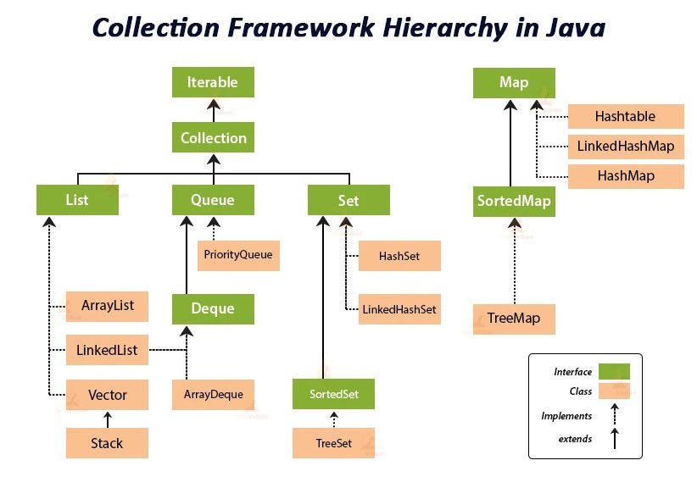
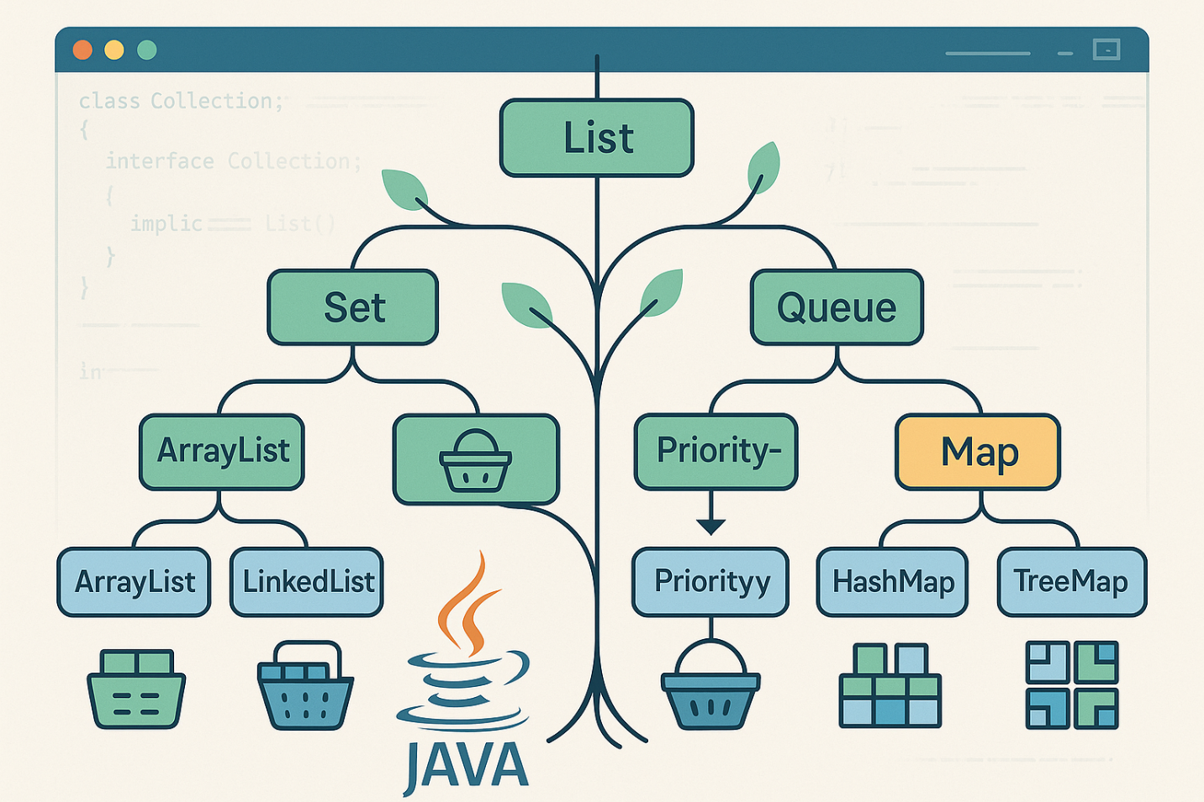

How to read this diagram
- Collection is the root interface
- It branches into:
  - List
  - Set
  - Queue
- Map is a separate hierarchy (does NOT extend Collection)

Key takeaway
If you need key–value → Map
If you need group of elements → Collection (List / Set)

2️⃣ List Interface – Order + Duplicates
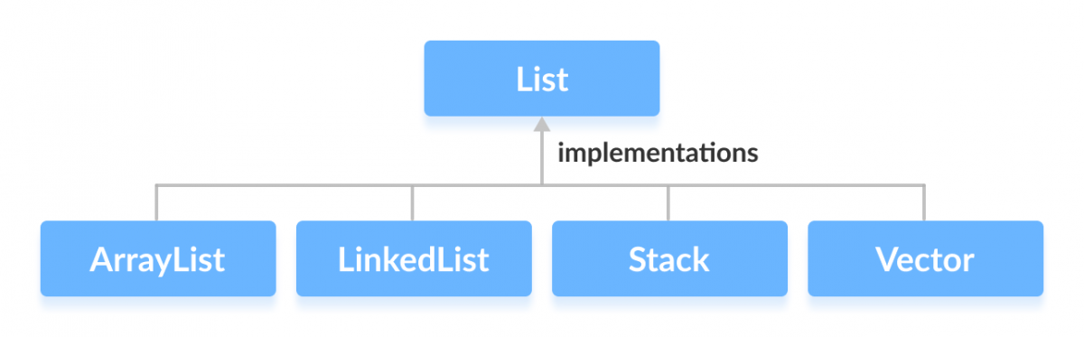
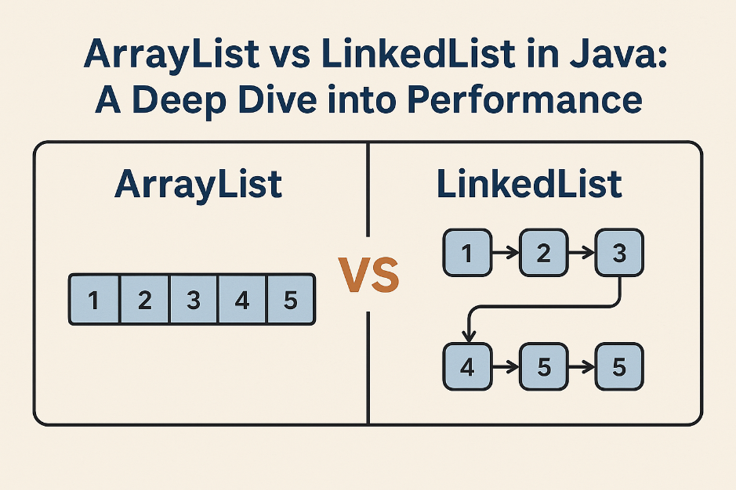

Diagram explanation
- Elements are stored in sequence
- Each element has an index
- Same value can appear multiple times

Real-life analogy
🎵 Playlist
0 → Song A
1 → Song B
2 → Song A (duplicate allowed)

When to use List
✔ Order matters
✔ Duplicates allowed
✔ Index-based access needed

3️⃣ ArrayList vs LinkedList (Internal Working)
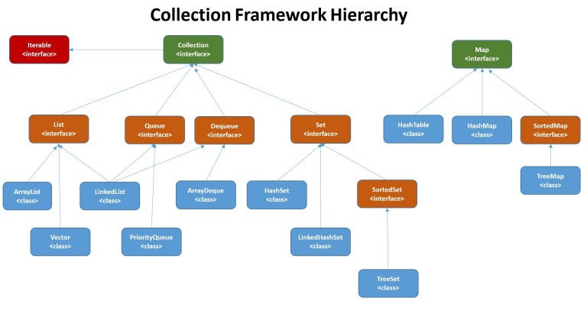
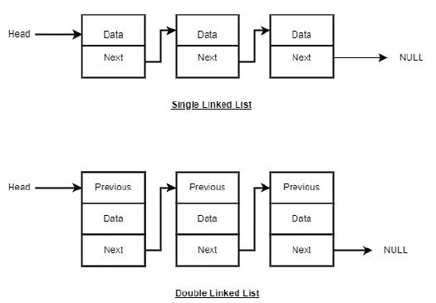

ArrayList (Diagram logic)
[ A ][ B ][ C ][ D ]
- Stored in continuous memory
- Fast get(index)
- Slow insertion in middle (shifting)

LinkedList (Diagram logic)
[A] → [B] → [C] → [D]
- Each node points to next
- Fast insert/delete
- Slow search

One-line rule
ArrayList → Read heavy
LinkedList → Insert/Delete heavy

4️⃣ Set Interface – Uniqueness Guaranteed
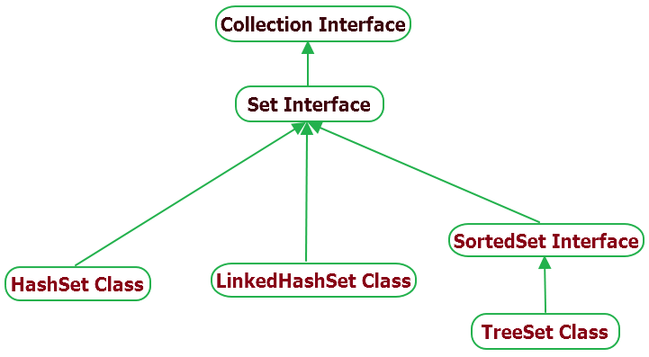
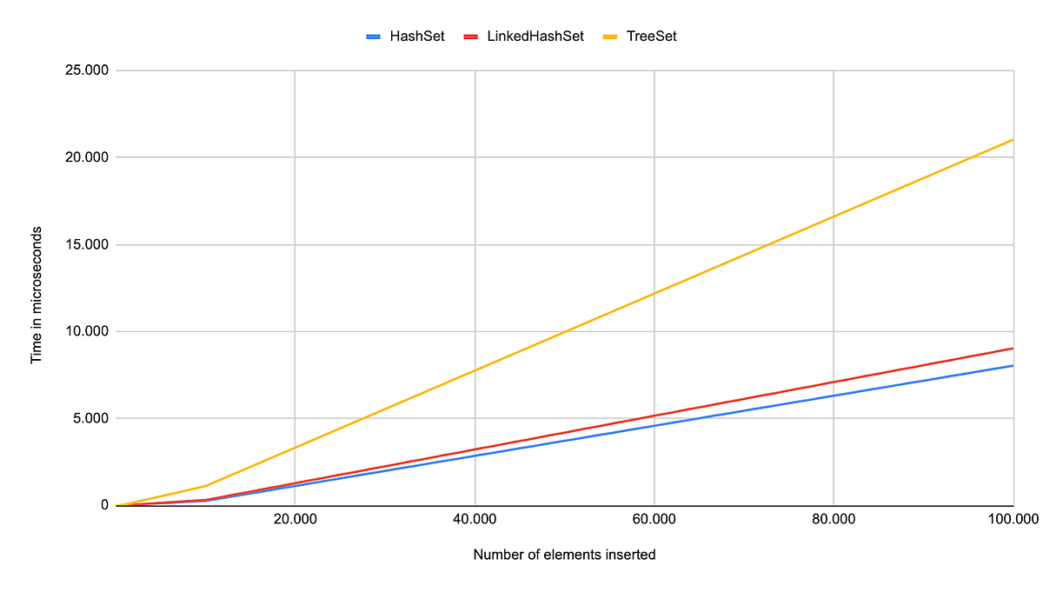

Diagram explanation
- No indexing
- Duplicate values are rejected automatically

Real-life analogy
🎓 Roll numbers
101, 102, 101 ❌ (duplicate rejected)

5️⃣ HashSet vs LinkedHashSet vs TreeSet
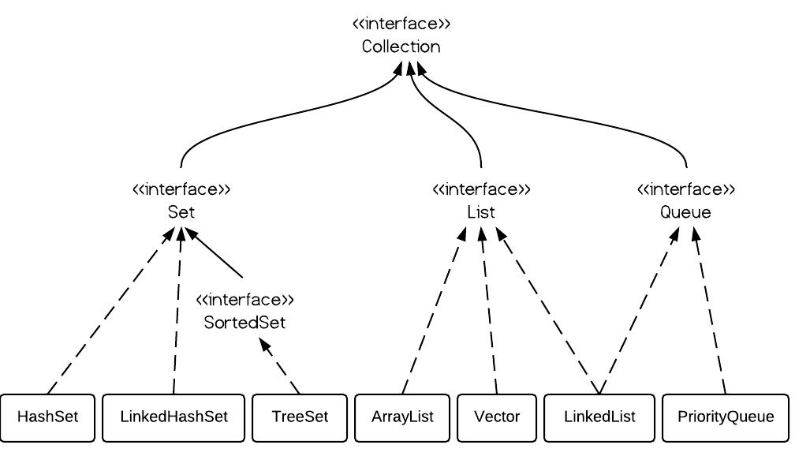
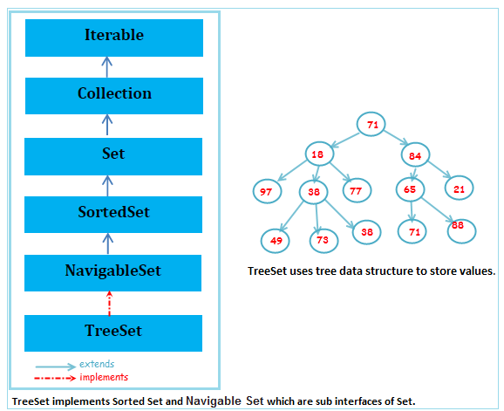

HashSet
102 101 105
- No order
- Fastest

LinkedHashSet
101 → 102 → 105
- Insertion order preserved

TreeSet
101 → 102 → 105
- Automatically sorted
- Uses Red-Black Tree

Exam trick
Sorted + Unique → TreeSet

6️⃣ Map Interface – Key → Value Relationship

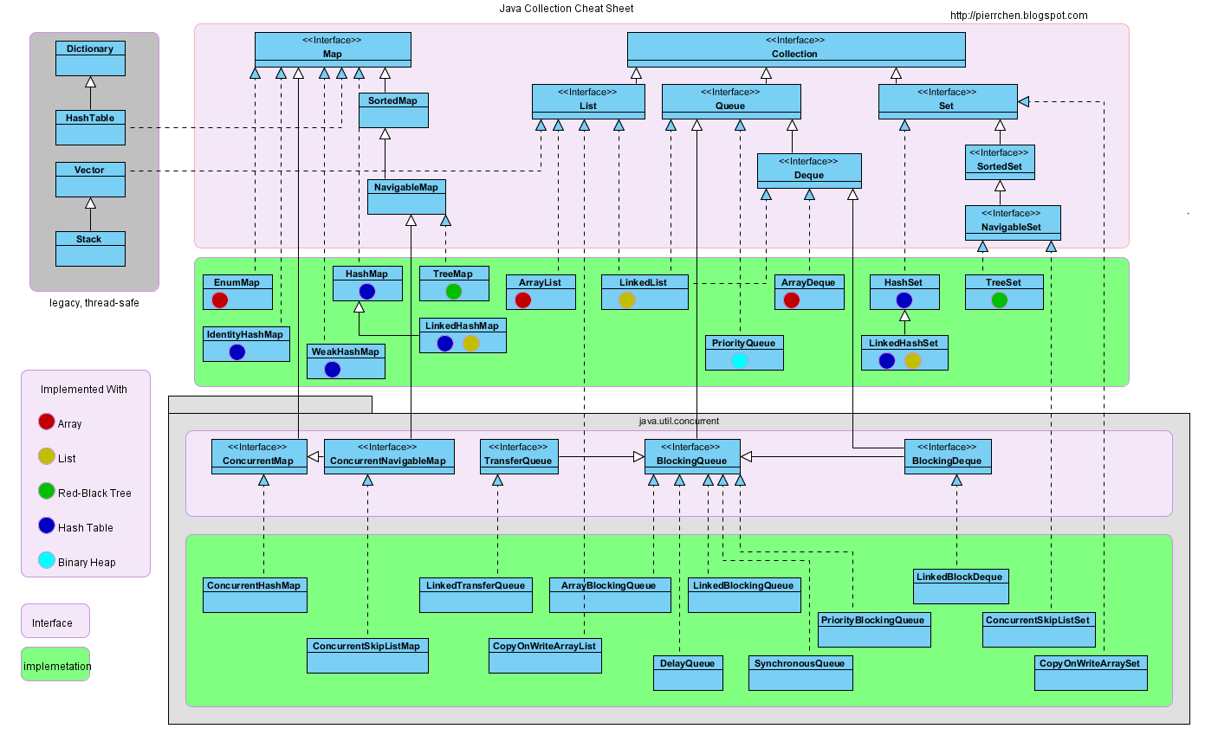

Diagram explanation
Key Value
101 → 85
102 → 90
- Keys are unique
- Values can repeat
- No duplicate keys allowed

Real-life analogy
🪪 Roll number → Marks

7️⃣ HashMap vs LinkedHashMap vs TreeMap
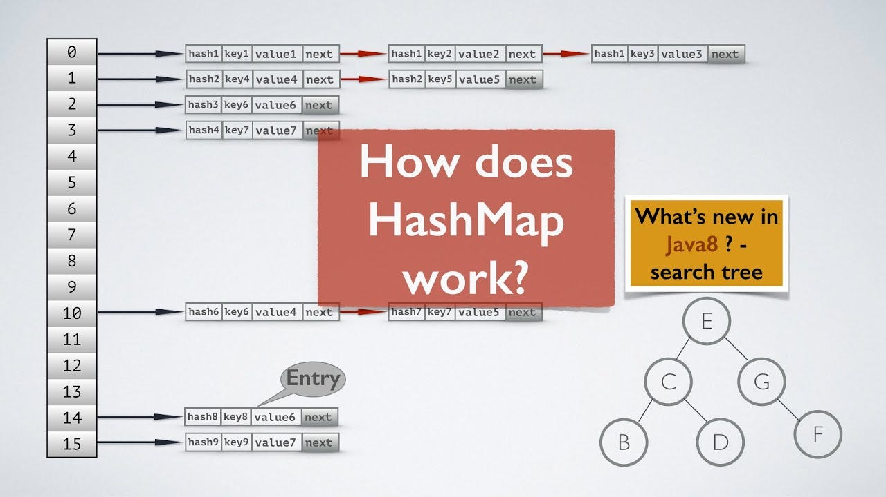

HashMap
- Random order
- Fastest lookup
- Uses hashing

LinkedHashMap
- Maintains insertion order
- Used in cache / history

TreeMap
- Sorted by key
- Uses Red-Black Tree
- Slower than HashMap

Interview rule
Performance → HashMap
Order → LinkedHashMap
Sorted → TreeMap

8️⃣ Time Complexity – Visual Memory Trick
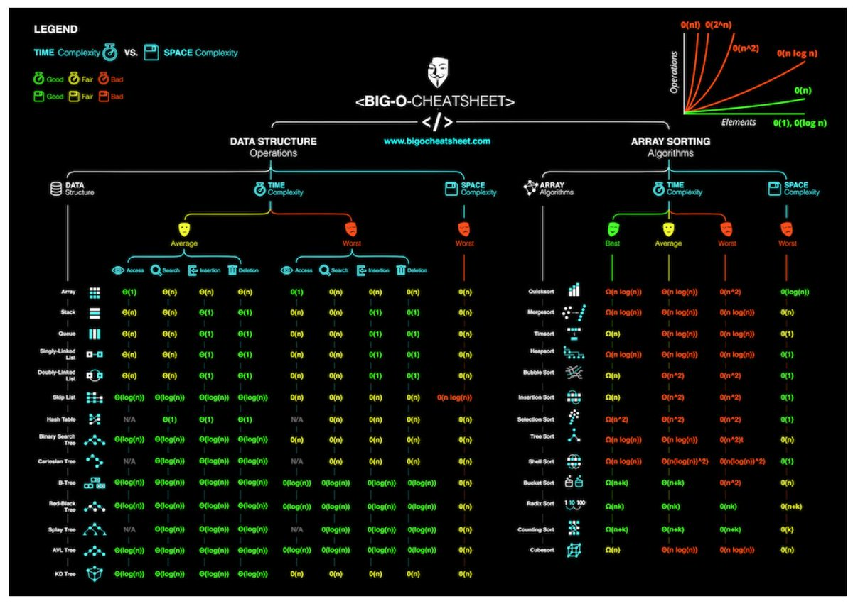

Structure | Idea to remember
ArrayList | Index based
LinkedList | Node traversal
HashSet / HashMap | Hashing
TreeSet / TreeMap | Tree (log n)

9️⃣ Ultimate Decision Diagram (EXAM GOLD)
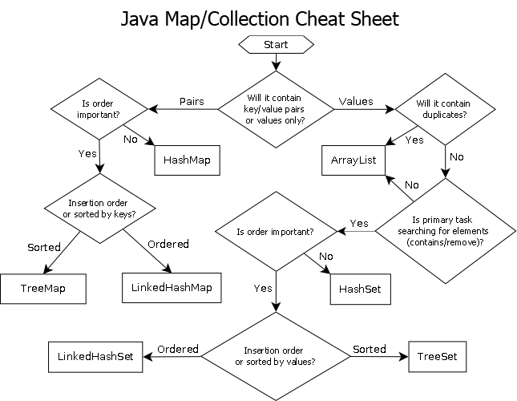
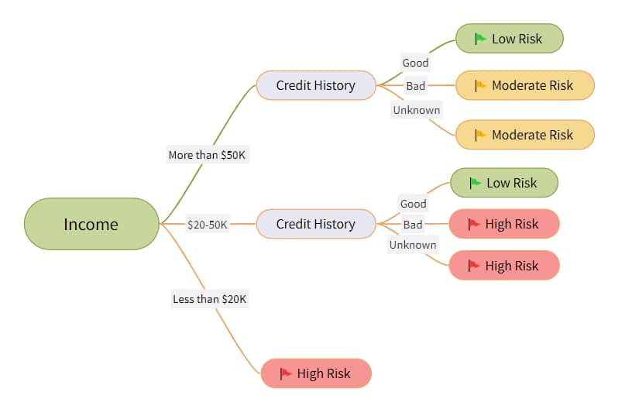

Ask these questions:
- Need key–value? → Map
- Need duplicates? → List
- Need unique? → Set
- Need sorted? → TreeSet / TreeMap

JAVA COLLECTIONS – MEMORY TRICKS FOR EXAMS

1️⃣ Big Picture Trick – “CLiSeQ, Map is Separate”
👉 Mnemonic:
Collection → List, Set, Queue
❌ Map is NOT part of Collection
🧠 Exam recall sentence:
“List, Set, Queue are children — Map lives alone.”

2️⃣ LIST – “ODI” Rule

🧠 ODI = Order, Duplicates, Index
✔ Maintains Order
✔ Allows Duplicates
✔ Supports Index-based access
📌 If a question mentions:
- Playlist
- Shopping cart
- Attendance register
➡️ Answer = List

3️⃣ ArrayList vs LinkedList – “AR vs LI”

🧠 ArrayList = AR
- Access fast
- Reading heavy

🧠 LinkedList = LI
- Links between nodes
- Insert/delete fast
📌 Exam shortcut:
“Reads → ArrayList, Writes → LinkedList”

4️⃣ SET – “NO DUP” Rule
🧠 Set = NO DUPLICATES
Think:
- Roll numbers
- Email IDs
- Aadhaar numbers
❌ Index ❌ Order (mostly)

5️⃣ HashSet, LinkedHashSet, TreeSet – “H-L-T Ladder”

🪜 Memory Ladder (Very Important)
Step | Set Type | Remember As
1️⃣ | HashSet | H = Hurry (fast, no order)
2️⃣ | LinkedHashSet | L = Line (order)
3️⃣ | TreeSet | T = Tree (sorted)
🧠 Sorted + Unique → TreeSet

6️⃣ MAP – “K-V = ID Card”
🧠 Map = Key → Value
Think:
- Roll no → Marks
- Username → Password
📌 Golden rule:
❌ Duplicate keys
✔ Duplicate values allowed

7️⃣ HashMap vs LinkedHashMap vs TreeMap – “H-L-T Again”
Reuse the H-L-T Ladder
Type | Trick
HashMap | H = Hashing = Fastest
LinkedHashMap | L = Linked = Order
TreeMap | T = Tree = Sorted
🧠 Performance → HashMap
🧠 Order → LinkedHashMap
🧠 Sorted → TreeMap

8️⃣ Time Complexity – “HALT” Trick

🧠 HALT
- HashMap / HashSet → O(1)
- ArrayList → get O(1)
- LinkedList → search O(n)
- TreeMap / TreeSet → O(log n)
📌 If you see tree in name → log n

9️⃣ Internal Working Memory Trick

🧠 Hash-based
- HashMap
- HashSet
➡️ Think: Bucket + Hashing

🧠 Tree-based
- TreeMap
- TreeSet
➡️ Think: Red-Black Tree

🔟 Common Exam Traps (VERY IMPORTANT)

❓ “Which allows duplicate values but not keys?”
🧠 Answer: Map

❓ “Which maintains insertion order?”
🧠 Answer: LinkedHashSet / LinkedHashMap

❓ “Which is fastest?”
🧠 Answer: HashMap / HashSet

1️⃣1️⃣ One-Line Super Memory Sheet
📌 List → Order + Duplicates
📌 Set → Unique only
📌 Map → Key → Value
📌 Hash → Fast
📌 Linked → Order
📌 Tree → Sorted

🏆 FINAL EXAM MANTRA
“Hash is fast, Linked remembers, Tree sorts.”

1️⃣ Why Special Handling is Required for Custom Key?
HashMap works in two steps:
- Uses hashCode() to decide bucket
- Uses equals() to check key equality inside bucket
If you don’t override both:
- Two logically equal objects will be treated as different keys
- Retrieval will fail

2️⃣ ❌ WRONG WAY (Common Mistake)

Custom Class (Without equals & hashCode)
class Employee {
int id;
String name;

Employee(int id, String name) {
this.id = id;
this.name = name;
}
}

Using as Key
import java.util.*;

public class TestMap {
public static void main(String[] args) {

HashMap<Employee, String> map = new HashMap<>();

Employee e1 = new Employee(1, "Amit");
Employee e2 = new Employee(1, "Amit");

map.put(e1, "Developer");

System.out.println(map.get(e2)); // ❌ Returns null
}
}

❓ Why null?
Because:
- e1.hashCode() ≠ e2.hashCode()
- Default equals() compares memory addresses
Even though data is same, objects are different in memory.

3️⃣ ✅ CORRECT WAY (Override equals & hashCode)

Custom Class with Proper Overrides
import java.util.Objects;

class Employee {
int id;
String name;

Employee(int id, String name) {
this.id = id;
this.name = name;
}

@Override
public boolean equals(Object obj) {
if (this == obj) return true;
if (obj == null || getClass() != obj.getClass()) return false;

Employee emp = (Employee) obj;
return id == emp.id &&
Objects.equals(name, emp.name);
}

@Override
public int hashCode() {
return Objects.hash(id, name);
}
}

Using It in HashMap
import java.util.*;

public class TestMap {
public static void main(String[] args) {

HashMap<Employee, String> map = new HashMap<>();

Employee e1 = new Employee(1, "Amit");
Employee e2 = new Employee(1, "Amit");

map.put(e1, "Developer");

System.out.println(map.get(e2)); // ✅ Works now
}
}

✔ Output:
Developer

4️⃣ Why Both Methods Are Required?
Method | Purpose
hashCode() | Determines bucket
equals() | Confirms key match

5️⃣ Contract Rule (VERY IMPORTANT FOR INTERVIEW)
If:
a.equals(b) == true
Then:
a.hashCode() must be equal to b.hashCode()
If you override equals() but not hashCode() → map breaks.

6️⃣ Real-World Best Practice
✔ Use immutable key fields
✔ Make fields final if possible
✔ Use Objects.hash() (clean & safe)
✔ Prefer record in Java 16+

7️⃣ Modern Clean Version (Using record – Java 16+)
record Employee(int id, String name) {}
That’s it.
equals() and hashCode() are automatically generated.

8️⃣ Interview Questions From This Topic

❓ What happens if hashCode() returns same value for all objects?
→ Performance degrades (acts like LinkedList)

❓ What happens if equals() is not overridden?
→ Duplicate logical keys allowed
Tttt
Below is a clear, interview-ready explanation + complete code demo of

🔹 Comparable vs Comparator in Java
This is one of the most frequently asked Java interview questions.

1️⃣ Core Difference (Quick Overview)
Feature | Comparable | Comparator
Package | java.lang | java.util
Method | compareTo() | compare()
Where defined? | Inside the class | Separate class or lambda
Sorting logic | Single natural order | Multiple custom orders
Used by | Collections.sort() | Collections.sort()

2️⃣ When to Use What?
✔ Comparable → Default / natural sorting
✔ Comparator → Custom sorting (multiple ways)

3️⃣ Comparable – Code Demo

🎯 Scenario: Sort Students by Roll Number (Natural Order)

Step 1: Implement Comparable
import java.util.*;

class Student implements Comparable<Student> {

int rollNo;
String name;
int marks;

Student(int rollNo, String name, int marks) {
this.rollNo = rollNo;
this.name = name;
this.marks = marks;
}

// Natural sorting by roll number
@Override
public int compareTo(Student s) {
return this.rollNo - s.rollNo;
}

@Override
public String toString() {
return rollNo + " " + name + " " + marks;
}
}

Step 2: Sort Using Collections.sort()
public class ComparableDemo {
public static void main(String[] args) {

List<Student> list = new ArrayList<>();

list.add(new Student(3, "Amit", 80));
list.add(new Student(1, "Neha", 90));
list.add(new Student(2, "Ravi", 85));

Collections.sort(list); // Uses compareTo()

System.out.println(list);
}
}

✔ Output:
1 Neha 90
2 Ravi 85
3 Amit 80

4️⃣ Comparator – Code Demo

🎯 Scenario: Sort Students by Marks (Custom Order)

Method 1: Separate Comparator Class
class MarksComparator implements Comparator<Student> {

@Override
public int compare(Student s1, Student s2) {
return s1.marks - s2.marks;
}
}

Using Comparator
public class ComparatorDemo {
public static void main(String[] args) {

List<Student> list = new ArrayList<>();

list.add(new Student(3, "Amit", 80));
list.add(new Student(1, "Neha", 90));
list.add(new Student(2, "Ravi", 85));

Collections.sort(list, new MarksComparator());

System.out.println(list);
}
}

5️⃣ Comparator Using Lambda (Modern Way – Java 8+)
Collections.sort(list, (s1, s2) -> s1.marks - s2.marks);
OR
list.sort(Comparator.comparingInt(s -> s.marks));

6️⃣ Multiple Sorting Example (Power of Comparator)
Sort by:
1️⃣ Marks
2️⃣ If marks same → Name
list.sort(
Comparator.comparingInt((Student s) -> s.marks)
.thenComparing(s -> s.name)
);

7️⃣ Interview Memory Trick
🧠 Comparable = Compare Myself
🧠 Comparator = Compare Others

8️⃣ Internal Working (Important)
When sorting:
- Java uses TimSort
- It repeatedly calls:
  - compareTo() (Comparable)
  - compare() (Comparator)

9️⃣ Common Interview Questions

❓ Can a class implement both?
✔ Yes

❓ What if compareTo() returns 0?
→ Objects considered equal in sorting

❓ Why use Comparator instead of Comparable?
→ When:
- You cannot modify the class
- You need multiple sorting logic
Comparable provides natural sorting inside class; Comparator provides custom sorting outside class.
Excellent — this is a high-value interview + exam topic.
Let’s cover everything step-by-step and clearly.

1️⃣ Sorting Using TreeSet with Comparator

🔹 Important Concept
TreeSet:
- Stores unique elements
- Maintains sorted order
- Uses Red-Black Tree
- Sorting is based on:
  - Comparable (natural order) OR
  - Comparator (custom order)

🎯 Example: Sort Students by Marks Using TreeSet + Comparator

Step 1: Student Class (No Comparable)
class Student {
int rollNo;
String name;
int marks;

Student(int rollNo, String name, int marks) {
this.rollNo = rollNo;
this.name = name;
this.marks = marks;
}

@Override
public String toString() {
return rollNo + " " + name + " " + marks;
}
}

Step 2: Use TreeSet with Comparator
import java.util.*;

public class TreeSetDemo {

public static void main(String[] args) {

// Sort by marks
TreeSet<Student> set = new TreeSet<>(
(s1, s2) -> s1.marks - s2.marks
);

set.add(new Student(1, "Amit", 80));
set.add(new Student(2, "Neha", 90));
set.add(new Student(3, "Ravi", 85));

for (Student s : set) {
System.out.println(s);
}
}
}

✔ Output (Sorted by Marks)
1 Amit 80
3 Ravi 85
2 Neha 90

⚠️ Important Trap
If two students have same marks:
set.add(new Student(4, "Karan", 90));
It may not be added.
Why?
Because:
compare() returns 0 → TreeSet treats as duplicate

✅ Correct Way (Avoid Duplicate Removal)
TreeSet<Student> set = new TreeSet<>(
Comparator.comparingInt((Student s) -> s.marks)
.thenComparing(s -> s.rollNo)
);
Now sorting:
- First by marks
- If same marks → by rollNo

2️⃣ Performance Differences

🔹 Sorting Using Comparable / Comparator
Method | Data Structure | Time Complexity
Collections.sort() | List | O(n log n)
TreeSet add() | TreeSet | O(log n) per insertion
Total TreeSet build | TreeSet | O(n log n)

🔹 Internal Working
Structure | Internal Mechanism | Complexity
ArrayList + sort | TimSort | O(n log n)
TreeSet | Red-Black Tree | O(log n)
HashSet | Hashing | O(1)

🧠 Key Interview Line
TreeSet maintains sorted order at insertion time, whereas List sorting happens after insertion.

3️⃣ Diagram Explanation

🔹 TreeSet Internal Working
85
/ \
80 90
- Balanced binary search tree
- Every insertion maintains sorted property
- Left < Root < Right

🔹 List + Sorting Diagram
Step 1: Insert
[80, 90, 85]
Step 2: Sort
[80, 85, 90]

🔹 Key Visual Difference
TreeSet:
Insert → Auto-sort → Unique
List:
Insert → Allows duplicates → Manual sort

JAVA QUEUE – CODE DEMO

📌 What is Queue?
Queue follows FIFO (First In First Out) principle.
🧠 Real-life example:
- Ticket counter
- Printer queue
- Call center waiting line

🔹 Queue using LinkedList (Basic Demo)
import java.util.*;

public class QueueDemo {
public static void main(String[] args) {

Queue<String> queue = new LinkedList<>();

// Adding elements
queue.add("Amit");
queue.add("Neha");
queue.add("Ravi");

System.out.println("Initial Queue: " + queue);

// Peek (view head without removing)
System.out.println("Head element: " + queue.peek());

// Remove head
System.out.println("Removed: " + queue.poll());

System.out.println("Queue after removal: " + queue);
}
}

🔑 Important Queue Methods
Method | Purpose
add() | Insert element
offer() | Insert safely
peek() | View head
poll() | Remove head
remove() | Remove head (throws exception if empty)

🔹 PriorityQueue Example (Important for Exams)
PriorityQueue orders elements based on natural sorting.
import java.util.*;

public class PriorityQueueDemo {
public static void main(String[] args) {

Queue<Integer> pq = new PriorityQueue<>();

pq.add(30);
pq.add(10);
pq.add(20);

System.out.println("Priority Queue: " + pq);

while (!pq.isEmpty()) {
System.out.println("Removed: " + pq.poll());
}
}
}

Output Order:
10
20
30
🧠 Remember:
PriorityQueue = Sorted queue (min-heap by default)

2️⃣ JAVA TREESET – CODE DEMO

📌 What is TreeSet?
TreeSet:
✔ No duplicates
✔ Automatically sorted
✔ Uses Red-Black Tree
✔ O(log n) operations

🔹 TreeSet Basic Demo
import java.util.*;

public class TreeSetDemo {
public static void main(String[] args) {

Set<String> names = new TreeSet<>();

names.add("Zara");
names.add("Amit");
names.add("Neha");
names.add("Amit"); // duplicate ignored

System.out.println("TreeSet: " + names);
}
}

Output:
[Amit, Neha, Zara]

🔹 TreeSet with Custom Sorting (Advanced Demo)
import java.util.*;

public class TreeSetCustomSort {
public static void main(String[] args) {

TreeSet<Integer> numbers = new TreeSet<>(Collections.reverseOrder());

numbers.add(10);
numbers.add(30);
numbers.add(20);

System.out.println("Descending order: " + numbers);
}
}

Output:
[30, 20, 10]

🔹 TreeSet with Custom Objects (Interview Level)
import java.util.*;

class Student implements Comparable<Student> {
int roll;
String name;

Student(int roll, String name) {
this.roll = roll;
this.name = name;
}

public int compareTo(Student s) {
return this.roll - s.roll;
}

public String toString() {
return roll + " - " + name;
}
}

public class TreeSetObjectDemo {
public static void main(String[] args) {

Set<Student> students = new TreeSet<>();

students.add(new Student(102, "Neha"));
students.add(new Student(101, "Amit"));
students.add(new Student(103, "Ravi"));

System.out.println(students);
}
}
🧠 Why Comparable?
TreeSet needs comparison logic to sort custom objects.

🔥 Queue vs TreeSet – Quick Comparison
Feature | Queue | TreeSet
Order | FIFO | Sorted
Duplicates | Allowed | Not allowed
Interface | Queue | Set
Complexity | O(1) | O(log n)

4️⃣ MCQs from Sorting

MCQ 1
If compare() returns 0 in TreeSet, what happens?
A. Element inserted
B. Exception thrown
C. Treated as duplicate
D. Sorting ignored
✅ Answer: C

MCQ 2
Which structure maintains sorted order automatically?
A. ArrayList
B. HashSet
C. TreeSet
D. LinkedList
✅ Answer: C

MCQ 3
What happens if Comparator logic is inconsistent with equals()?
A. Compile error
B. Runtime crash
C. Unexpected behavior
D. Sorting stops
✅ Answer: C

MCQ 4
Which is faster for search?
A. TreeSet
B. HashSet
C. ArrayList
D. LinkedList
✅ Answer: B

MCQ 5
Time complexity of TreeSet insertion?
A. O(1)
B. O(n)
C. O(log n)
D. O(n log n)
✅ Answer: C

5️⃣ Advanced Interview Question

❓ Why TreeSet removes duplicates based on Comparator?
Because:
- It uses comparison result to decide equality
- If compare(a,b) == 0
→ TreeSet assumes they are equal
It does NOT use equals() for duplicate detection.

6️⃣ Final Exam Summary
Feature | Comparable | Comparator | TreeSet
Sorting | Natural | Custom | Auto sorted
Duplicates | Allowed in List | Depends | Not allowed
Complexity | O(n log n) | O(n log n) | O(log n)

